OWYHEE COUNTY COMPREHENSIVE PLAN

2026-2040
Adopted by Resolution 26-XX
Insert adoption date here

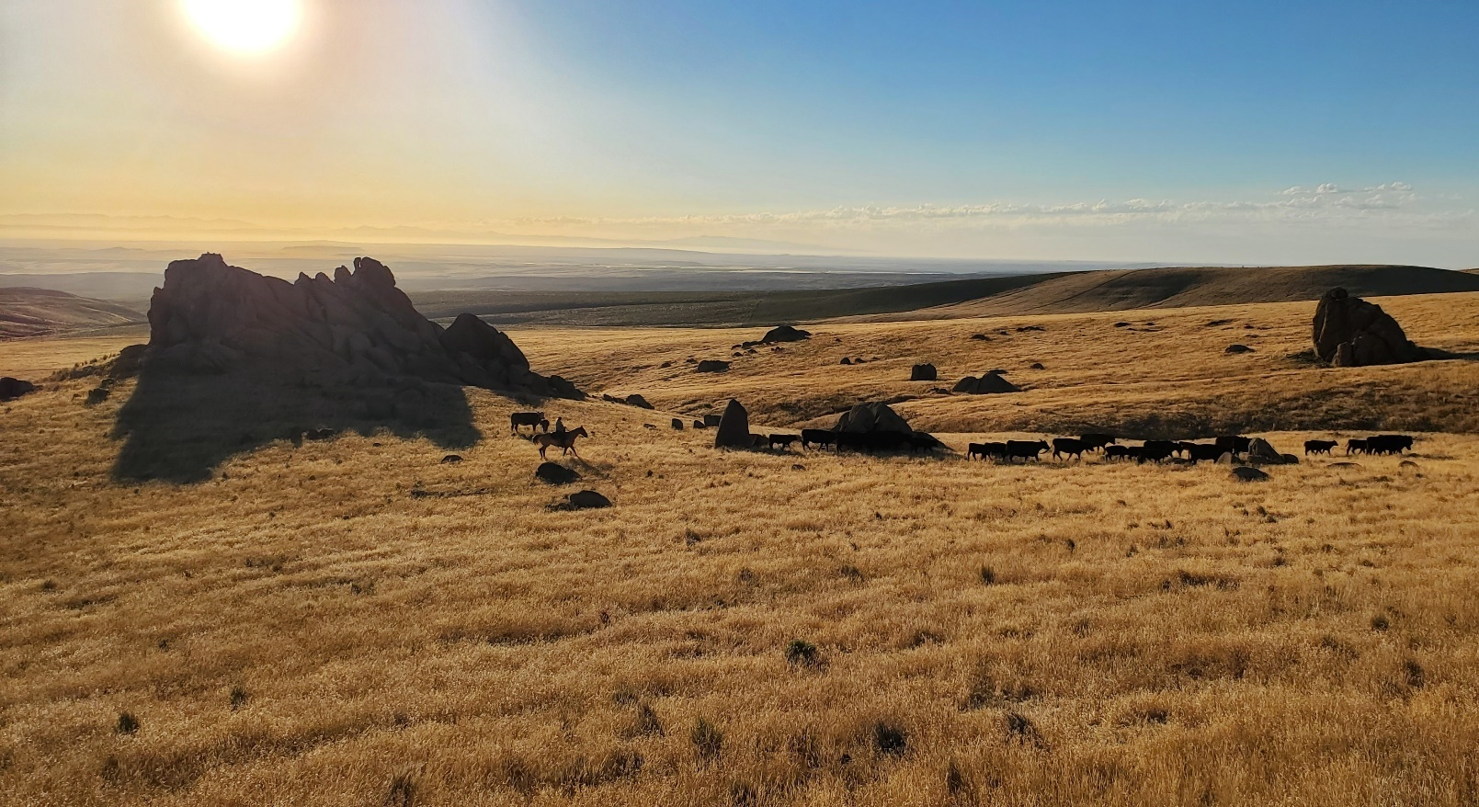

Contents
C. Comprehensive Planning 2
D. OWYHEE COUNTY LAND USE AND MANAGEMENT PLAN FOR FEDERAL AND STATE MANAGED LANDS 4
1. PLANNING COMPONENTS 4
Private Property Goal: 6
Private Property Objectives: 6
B. LAND USE: 7
C. Agricultural Land Use: 9
D. Multi-use Land Use: 10
E. Residential Land Use: 10
F. Commercial Land Use: 11
G. Industrial Land Use: 11
H. Historic Land Uses and Areas: 12
J. Existing Uses: 13
a. POPULATION CONSIDERATIONS 15
b. Recreation and Special Areas 16
Housing: 19
c. Natural Resources: 20
Wild and Scenic Rivers 25
Community Design: 28
Economic Development: 30
Capital Infrastructure 32
Public Services and Facilities: 33
Utilities and Energy: 34
Hazardous Areas: 36
Transportation: 36
School Facilities Goals: 43
K. Plans Incorporated By Reference 43
L. Implementation 44

Owyhee County History
In the early nineteenth century, the area to become Owyhee County was inhabited by the Shoshone, Bannock, and Northern Paiute Indians. In 1818, members of an expedition formed by the North West Fur Company and under the leadership of Donald MacKenzie reached the Boise Valley. His expedition included natives of the Sandwich Islands known as “Owyhee’s.” (officially, the island’s name was changed to the Hawaiian Islands in 1840. Owyhee is an older English spelling of the word Hawaii) Three natives left to explore southwestern Idaho that winter. They never returned, feared to have been lost or killed by Indians. Since that time, the country in which they disappeared has been called the “Owyhee country”.

Prospectors ventured into Owyhee country in 1863 discovering gold and silver. The Cities of Boonville (later changed to Dewey) DeLamar, Ruby City, Silver City, and Wagontown, were population centers as a result of this boom era which lasted until about 1912. During that time, millions of dollars of minerals were taken from the Owyhee Mountains. During the mining boom, there was a demand to feed the population in those mining towns. Range cattle from Texas and California were trailed to the area because of the high demand for beef. Many ranches had orchards and supplied fruit and vegetables to the mining towns as well. Ranching and livestock grazing became a permanent staple of the Owyhee County economy as ranchers settled in the area, laying claim to private lands and the waters which provided the source for stock water.

Owyhee County became the first county organized by the Idaho Territory Legislature on December 31, 1863. The first county seat was Ruby City. In 1867, the county seat was moved to Silver City. Because of the remote location and difficult winter travel the county seat was relocated to Murphy in 1934. By oversight, the Idaho legislature did not officially designate Murphy as the county seat until 1999. The county courthouse existed there for 65 years prior to the designation.

The 1934 relocation of the county seat symbolized the transition from mining, centered in the Silver City area, to agriculture, which today forms the central base of the area’s economy. Irrigation has been developed all along the Snake River turning desert into lush farmland and contributing to economic growth over the years.

Location
Owyhee County, the second largest in Idaho, occupies the entire southwestern portion of Idaho covering a 4,888,960 acre area. Some of the most rugged and arid land lies within Owyhee County which is bordered by the Snake River on the north, the State of Oregon on the west, the State of Nevada on the south and the County of Twin Falls on the east. Populations have been mostly confined to the lowlands along the Snake River. The principal communities include Homedale, Marsing, Murphy, Grand View, and Bruneau. Other centers important to the outlying population of the County include Three Creek, Murphy Hot Springs, Riddle, Grasmere, Indian Cove, Hot Springs, Triangle, Wickahoney, Fairy Lawn, Oreana, Wilson, Givens Springs, Silver City, DeLamar, South Mountain, Pleasant Valley and the Duck Valley Indian Reservation.

Comprehensive Planning
It is the intent of the people of Owyhee County to preserve and protect the historic customs, traditions, and way of life unique to Owyhee County in so far as this is consistent with a reasonable and orderly rate of growth and development and with the protection of private property rights.

It is also the intent of the people of Owyhee County to use this plan as a guide and framework which will provide for reasonable and sound land development, a safe and healthy living environment, and a successful economic climate while at the same time conserving the best of the historic ranching and farming tradition and way of life.
This plan sets forth the goals and objectives determined by the people of Owyhee County to guide their communities in future growth and development decisions. Therefore, this plan will be used as a “working” document to guide land use and development. Decisions of the Planning and Zoning Commission and the Board of County Commissioners regarding land use must be consistent with this Plan and the ordinances which are enacted to implement the Plan. It is self-evident that changes will occur in the Communities. Therefore, subject to constraints contained in state law, this Plan is subject to amendment to address changing status and needs regarding land use within the county. It must be a truly public document, requiring full public participation in its continued use and future changes. Within the time frames established by state law, on a regular basis the Planning and Zoning Commission and the Board of County Commissioners will review the plan and update it as necessary to meet the changing needs of the County.

The Board of County Commissioners have decided that zoning should be implemented and administered through a Planning and Zoning Commission, composed of members appointed by the Board pursuant to membership requirements outlined in state law. The Planning and Zoning Commission is appointed to hear and decide all requests for conditional use permits, with their decisions final unless appealed to the Board of County Commissioners. The Planning and Zoning Commission is also charged with recommending amendments to this Plan and to zoning ordinances to the Board of County Commissioners where the final decisions on such matters are made.

Amendments to the plan will follow the directions set forth in Idaho Code, but for the convenience of persons using this Plan, those directions are stated as follows:

- Upon any request to amend or repeal the plan, the Planning and Zoning Commission shall hold a public hearing giving at least 15 days public notice in the newspaper designated by the Board of County Commissioners for publication of legal notices, with notices provided also by posting at various locations throughout the county and in notices to newspapers and radio stations and mailed notices to all taxing districts within the County;
- After the public hearing, the Planning and Zoning Commission will make its recommendation to the Board of County Commissioners who will conduct a public hearing, following the same conditions stated in paragraph 2. After such public hearing, the Board will make its decision as to amendments to the Plan.
- No amendment to the Plan is effective until it is adopted by the Board and implemented, where necessary, by amendments to the zoning ordinances.

OWYHEE COUNTY LAND USE AND MANAGEMENT PLAN FOR FEDERAL AND STATE MANAGED LANDS
In the early 1990s, the Board of County Commissioners established a land use planning committee to serve as its advisors on matters relating to management by federal and state agencies of the federal and state lands which make up a great majority of all lands in the County. An interim plan was developed by that committee and then approved by the Board. Subsequently, the Board changed the name of the committee to the Natural Resources Committee and established its existence and duties by ordinance. In 2009 the latest version of the Owyhee County Land Use and Management Plan (Natural Resources Plan) for the federally and State Managed Lands was adopted.

This Comprehensive Plan which is directly applicable to planning for the private lands in the County has been developed for consistency with the Natural Resource Plan applicable to the federally and State Managed Lands. The nature of the checkerboard pattern of private lands, state lands, and federal lands makes it imperative that the Planning and Zoning Commission always keep in mind the impact that management actions on the federal lands and state lands will have on private land, and that the Commission insist on compliance with this Plan by federal and state land management agencies where the law allows it to insist on such compliance. The Plans must be implemented in coordinated fashion, and should complement each other in planning for the future of Owyhee County.

The Planning and Zoning Commission will coordinate its activities with the Owyhee County Natural Resources Committee to ensure proper planning for the entire County and the protection of private property rights which are critical to the custom, culture, and economic stability of Owyhee County.

PLANNING COMPONENTS

- PRIVATE PROPERTY RIGHTS
Private property means all property protected by the Fifth Amendment and the Fourteenth Amendment of the Constitution of the United States and Section 13, Article I of the Constitution of the State of Idaho.
Private property rights include but are not limited to:

- The right to own property.
- The right to use property as one wishes for one’s own benefit as long as it does not harm others.
- The right to exclude others from the property.
- The right to sell or dispose of property.
- The right to hold and enjoy property without excessive or unreasonable property taxes or arbitrary and unreasonable government restrictions.
This component provides an analysis of provisions that may be necessary to assure that land use policies, restrictions, conditions and fees do not violate private property rights, adversely impact property values, or create unnecessary technical limitations on the use of property.

Everyone shall have the freedom to make full use of their property, so long as they do not harm the rights or property of other persons while doing so, and are in compliance with the Comprehensive Plan and ordinances. The Plan and implementing ordinances must be designed so that the Planning and Zoning Commission and Board of Commissioners can and will apply all regulations and actions involving property rights uniformly to all those involved and will assure that there is reasonable protection of existing property rights from being adversely impacted by new or expanded development or changes in use of adjacent properties.

Private property rights are essentially and effectively negated if property taxes become excessive or unreasonable; Constitutional rights to property become meaningless when property taxes rise to the level of quasi-confiscation. Property values can be negatively affected where property taxes become excessive or unreasonable. Therefore, all decisions by the Board of County Commissioners and the Planning and Zoning Commission should consider the potential tax burden to the taxpayers of the county which may result as a consequence of such decision. Land use changes or developments should not be approved when such changes or developments will result in excessive or unreasonable tax increases to the existing taxpayers of the county. Applicants for changes in land use or development may be required, at the option of the Planning and Zoning Commission, to demonstrate that such changes or developments will not have an adverse impact on the valuation of land in the county, the existing property tax structure, or the existing taxpayers of the county.

County government may properly regulate or limit the use of private property, based upon its authority and responsibility to protect public health safety and welfare. It may abate public nuisances, terminate illegal activity, and establish building codes, and safety standards.
However, if government destroys any of the fundamental property rights, such activity could constitute a compensatory taking. In a taking assessment, courts generally consider both the purpose of the government’s action and the degree to which it limits an owner’s property rights.

The purpose of the Planning and Zoning Commission is to assure that all regulatory land use activities are properly administered in accordance with federal and state law to include the Idaho Local Land Use Planning Act of 1975 as amended, the Attorney General’s Regulatory Takings Act guidelines, and Owyhee County planning and zoning ordinances. Owyhee County wishes to assure that land use policies, ordinances, restrictions, conditions and fees do not violate private property rights, adversely impact private property values or create unnecessary technical limitations upon the use of the property which could create an unconstitutional taking of private property rights. In order to evaluate each related action, the county will ask the following questions, which have been included in a checklist for state agencies by the Idaho Attorney General. If any question is answered in the affirmative, the action will need to be reexamined:
- Does the regulation or action result in the permanent or temporary physical occupation of all or a portion of private property?

- Does the regulation or action require a property owner to dedicate a portion of property or grant an easement without full compensation?

- Does the regulation deprive the owner of all economically viable uses of all or any part of the property?

- Does the regulation have a significant impact on the landowner’s economic interest?

- Does the regulation deny a fundamental attribute of ownership?
Does it deny the right to possess, exclude others or dispose of all or a portion of the property?

- Does the regulation or action serve the same purpose that would be served by directly prohibiting the use or action, and does the condition imposed substantially advance that purpose?

Private Property Goal:
To protect, enhance and insure private property values and rights within the national, state, and local laws.

Private Property Objectives:
- To review all land use decisions, policies, procedures and ordinances keeping the county policy as stated above in mind. To encourage the fullest use of the land in Owyhee County, as long as such use is compatible with existing surrounding uses and with any siting requirements established by national, state or local law.
- To recognize the value of all land uses and protect the right to those uses, in recognition of health, safety and welfare standards and in compliance with the Comprehensive Plan.

- To recognize that surrounding property owners also have the right for protection of their property rights and values.

- To protect existing agricultural uses and rights, as allowed under State law.
- To provide for protection of the effective operation of canals and irrigation systems from detrimental impacts of growth, and to provide for protection of existing water rights.

- To ensure that application fees for development are based on actual costs to process that application and are not of such a level as to prohibit development.

- To ensure that standards on development are equitable and applied equally.

- To follow state law in the treatment of heirs to an estate as to the protection of their property rights.

- To ensure protection of legally existing uses and facilities through ordinances addressing nonconforming status.

LAND USE:
General Considerations
The federal and state governments control 82.7% of the land situated within Owyhee County. Another 10.8% is classified as “rangeland”. While this is not a precise, legally defined term, rangeland will be defined as that land so classified by the NRCS (formally SCS). Some of the rangeland in Owyhee County is located far from urbanized areas, lacks developed roads, fire protection, emergency services, schools and utilities, and may not have a predictable water source. Because of these factors some of this land may not be suitable for residential development.

State and Federal regulatory agencies have authority and jurisdiction over many aspects of development as it relates to various environmental aspects. Comments and information should be solicited from these agencies when a proposed project will be subject to state or federal regulations.

A chart showing proportionate land ownership and uses is affixed as Appendix I. Irrigated agriculture is the second largest land use in the County. Most of this is located
adjacent to the Snake River and its tributaries. The agricultural land varies greatly in productivity from prime to marginal.

Scattered residential parcels are found in some parts of the agricultural areas. A number of small lot residential subdivisions are located in marginal agricultural lands.

There are some Confined Animal Feeding Operations (CAFO’s), industrial uses, and commercial uses located within the county. The Board of Commissioners, by resolution, has established a checklist for consideration of proposed siting of CAFOs. The Idaho legislature has now enacted a law requiring that milk permits for dairies are conditioned upon county certification that any new or expanding dairy farm is in compliance with county livestock ordinances and evidence that the operator has a valid water right to supply adequate water for the new or expanding use.
The Idaho legislature has also enacted a law which authorizes the county to require an applicant for siting of a CAFO to submit an odor management plan as part of an application for siting, and to request the department of agriculture to form a CAFO siting advisory team to provide a suitability determination for a proposed site. These laws relating to CAFO siting dairy operations are premised upon findings by the legislature that confined animal feeding operations increase social and environmental impacts in areas where the facilities are located. Within that legislative finding, within the terms of the state laws, the resolution passed by the Board of Commissioners and any further resolutions and/or ordinances regarding CAFO siting, each application will be judged on its own facts. Because of the legislative findings of impacts, as well as concerns expressed by the Board of Commissioners in its siting resolution, each CAFO proposal, as defined in Owyhee County Zoning Ordinance will be subject to a conditional use permit.

Area of Impact:
The protection of agricultural uses, even within the Area of Impact is a high priority. Use in areas of impact should allow for the mixture of larger agricultural parcels and smaller parcels for other development. Subdivisions within the impact area shall be controlled by county plans and ordinances or by stand-alone documents adopted by the Board of County Commissioners specific to the Area of Impact.

It is important that the Areas of Impact be looked to as areas in which the developing needs of the cities will be recognized and accommodated, where consistent with this Plan and county ordinances or other relevant law. The original purpose of establishment of the concept of Areas of Impact was to allow for ordered development consistent with the availability of services needed for residential, commercial, and industrial uses, usually offered by a city rather than county government. That concept will be kept in mind, tempered by land use priorities as stated in this Plan and the concern for existing and vested private property rights. At this time, Homedale and Marsing Fire Districts and the Marsing Ambulance District have implemented impact fees, and it is anticipated that more taxing districts will follow suit.

ii. Zoning Map:
A map of land use zones in Owyhee County has been developed and adopted by the Board of County Commissioners. Other land use planning maps have been developed and adopted as a part of this plan to help inform future land use decisions. .Existing uses may continue as a non-conforming use, subject to local, state, and federal rules governing such non-conforming uses.
Any proposed expansion or change of use will be subject to the current zoning at the time of the requested change or expansion. Uses which are not allowed in that zone may seek a conditional use permit unless the requested use is listed as a prohibited use.
As the Comprehensive Plan is updated, new or modified zones may be created. As part of this process, consideration of existing commercial and industrial uses and platted residential subdivisions will be taken into account and may be zoned according to their use at the time of the adoption of the zoning map if such use is reasonable and appropriate to that area and does not create a substantial incompatibility to adjacent property. However, preexisting nonagricultural residential, commercial, or industrial uses will continue as a nonconforming use and will not be rezoned simply because of their presence. Nothing in this plan precludes landowners from seeking a rezone if they wish to go through the process established for rezones, but spot zoning of individual parcels is not permitted

The official land use map is color coded to indicate the following land uses: agricultural, commercial, industrial, residential, multi-use, and historical. A map depicting the boundaries of each new or modified land use zone will be adopted so that landowners and users can determine with specificity the zone in which their land lies. If a parcel of land has two zoning designations, the whole parcel will be given the benefit of the more permissive zoning designation..

Agricultural Land Use:
The preservation of historical and customary agricultural and range use is important to the citizens of Owyhee County, who base a large portion of their economy on agriculture. Maintaining viable tracts of prime agricultural and rangeland is important for the local economy and way of life.
The purpose of the agricultural zone is to preserve and protect the decreasing supply of agricultural land, and to control the infiltration of urban development into agricultural areas which will adversely impact agricultural operations and will result in an adverse impact on the county’s tax base and economy.

This Plan has been developed with the “Right to farm” mandated by the Idaho legislature in mind. The legislature has mandated that no owner may be deprived of full and complete use of agricultural land for production of any agricultural product by land use restrictions enacted after the commencement of the agricultural use.

It is the intent of the Comprehensive Plan to recognize the spirit and the letter of the Idaho Code with respect to agriculture. It is also the intent of the Comprehensive Plan to recognize that residential use by the farm or ranch owner and his family or his agents and employees is usual, and customary with agricultural use. Furthermore, the Comprehensive Plan also recognizes that certain other uses such as but not limited to buildings, areas, or road side stands for the sale of agricultural products produced on the farm or ranch; buildings or areas for the storage or processing of agricultural products produced on the farm or ranch; and buildings or areas for the storage, manufacture or repair of machinery or vehicles used or to be used on the farm or ranch are usual and customary with agricultural use.

However, it is not the intent of the Comprehensive Plan to allow unregulated residential, industrial, or commercial uses within the agricultural zones when they are not part of a normal and customary use related to the operation of an individual farm, ranch, or agricultural unit.
Agricultural Use is defined in the Zoning Ordinance. The Agricultural land use zone will include all types of agricultural and range operations, single family homes, including manufactured homes, and any accessory buildings necessary for operation of the agricultural use. Related industrial land uses may be allowed after careful consideration of its impact on surrounding agricultural uses. Commercial use tied to neighborhood needs might be allowed under a conditional use permit after review of potential impacts on the surrounding areas.

Multi-use Land Use:
There are areas within the county where commercial growth is to be expected, and where certain commercial growth is desirable. As residential development increases, there will be a demand for, and need for, certain commercial uses which are compatible with residential development. It is desirable from the county’s standpoint that commercial uses be attracted to areas along main transportation routes and corridors where commercial uses might be reasonably expected to locate, in order for the county to better provide the general governmental services which become necessary with commercial development.

It is desirable to provide multi-use zones in which residential, agricultural and most
commercial uses are allowed, subject to the county Zoning Ordinance. Other uses may be permitted by conditional use permit. These areas are identified as Multi-Use zones.

Residential Land Use:
Residential zones are located in areas where higher-density development already exists, and where infrastructure and services can support additional growth. Residential areas eliminate the problems of distance, lack of developed roads, fire protection, emergency services, schools, utilities, and a predictable water source.
Residential zones are generally located on marginal agricultural lands, waste areas, or rangelands that are reasonably accessible, situated near State highways or major County roads, and within reasonable proximity to schools and public services.
The residential land use is suitable for residential living and subdivisions. Developments are encouraged to incorporate a reasonable measure of rural atmosphere, country life style, and open space. High density subdivisions should be located in cities and/or where city services are available. All developments shall meet the health and safety regulations set forth by South West District Health and the state as to the installation of water and septic systems on sufficient lot sizes.

Other uses found in this section include appropriate agricultural, public, or semi-public facilities compatible with agricultural and residential use. Other uses may be permitted by conditional use permits. Subdivisions of up to 10 lots should be allowed in these zones. Densities greater than one home per parcel may be allowed only by conditional use permit. The term “parcel” is defined in the zoning ordinance.

When determining lot or parcel densities, Planning and Zoning may consider water information available, the impact the proposed development may have upon the transportation system, the local school system, other public or County services, and other surrounding land uses.

No residential parcel will be developed without legal access to a public street or road (either directly, or by use of a private road meeting standards for ingress and egress and emergency response). It shall be the responsibility of the property owner whose property is being developed to meet road standards.

Commercial Land Use:
Commercial use in Owyhee County has traditionally been located along the state highways and County roads and in incorporated areas, serving the consumer needs of residents, agricultural needs, and travelers in the area. It is the desire of the citizens of Owyhee County to continue such uses along or within the area of the highway corridors, but to cluster these endeavors to avoid “strip” commercial development. New commercial
development should be encouraged to locate within the city limits or impact areas, or where appropriate within multi-use zones.

Planning and Zoning may consider the impact the proposed development will have upon the aquifer, the County transportation system, the local school system, other public or County services, and other surrounding land uses.

No commercial parcel shall be developed without legal access to a public street or road. Should such street or road not meet current road standards, the County may require the developer to improve the road or street to current standards. Off street parking shall be adequate to meet the needs of the commercial use. Access to major county roads should be limited so as to not negatively impact traffic flow or safety.

Industrial Land Use:
It is the desire of the citizens to allow and encourage industrial development in the appropriate industrial zones, and light industrial uses in industrial or multiuse zones The Planning and Zoning Commission will encourage new industrial business to locate in Owyhee County subject to all local, state, and federal regulations. Industrial zones and uses should be located within areas of impact where city services are more likely to be available or in already established industrial or multiuse zones.

Industrial use may include light industries, small manufacturing plants, processing plants, and other related uses which are deemed compatible to the county’s other uses. Heavy industrial uses are those uses that cause a potentially detrimental impact beyond their property lines such as noise, odor, vibration, glare, smoke, and dust. Planning and Zoning will consider the impact the proposed development will have upon the aquifer, the County transportation system, the local school system, other public or County services and other surrounding land uses.

No industrial parcel shall be developed without the legal access to a public street or road. Should such street or road not meet current road standards , the County may require the developer to improve the road or street to road standards. Off street parking appropriate to the industrial use shall be required. Access to major county roads should be limited so that traffic flow or safety is not compromised.

Historic Land Uses and Areas:
One of the prime attractions in Owyhee County is the historic town site of Silver City. Silver City will continue to be preserved in its present form as much as possible. Commercial development which is incompatible with the town’s historic character will not be allowed. As interest in historic preservation increases, additional areas and sites may be identified and a program started to mark and provide historic background information. Sites on private property will not be marked or shown on maps without the owner’s written permission.
There are many pioneer cemeteries located in Owyhee County. Three elected commissioners are responsible for the management of the cemetery districts.

Location

Owyhee County, the second largest county in Idaho, occupies the entire southwestern portion of Idaho covering a 4,888,960 acre area. Some of the most rugged and arid land lies within Owyhee County which is bordered by the Snake River on the north, the State of Oregon on the west, the State of Nevada on the south and the County of Twin Falls on the east. Populations have been mostly confined to the lowlands along the Snake River. The principal communities include Homedale, Marsing, Murphy, Grand View and Bruneau. Additional areas important to the outlying population of the County include Oreana, Wilson, Givens Hot Springs, Pleasant Valley, South Mountain, Duck Valley Indian Reservation, Grasmere, Riddle, Three Creek, Indian Cove, Murphys Hot Springs, Triangle, Silver City, and DeLamar.

This plan recognizes mining and ranching as a rich part of Owyhee County History that are historic land uses. It is important for the county to consider the impact of current mining practices and plans within the county in order to prevent infringement on historical sites. Nothing in this plan is meant to conflict with State or Federal laws.

Historic Land Use objectives:
- Encourage the preservation of historic districts, town sites and areas of Owyhee County. The county should request that the Director of the Owyhee County Historical Society, in cooperation with the Owyhee County Historic Preservation Commission, identify and document known historic sites in the county. As identifications are made, the list of sites currently in place should be added to the list maintained at the Owyhee County Historical Society.
- A determination should be made by the Historic Preservation Officer as to how to store historic data provided by private land owners that do not want the data publicized, marked, or shown on maps.
- Explore a voluntary register for property owners who wish to have their historic properties documented and preserved. The county should request that the Historic Preservation Officer provide an updated list of known historic sites to the county for inclusion on county maps.

- Discourage commercial energy, or any other development that may have an adverse effect on historic districts and sites. As mining companies continue to explore in Owyhee County, the County Commissioners should have a list of historic properties available which may assist them as they work with businesses, State and Federal agencies.

- The Historic Preservation Officer and Historic Preservation Commission should continue conducting and preserving oral histories as a vital avenue for capturing the county’s unique cultural heritage. Efforts should be made to increase public awareness of these oral histories through improved visibility and promotion

Other Land Uses:
The county may establish special areas and site categories to address unique characteristics of the land or environment. This may include identifying public lands, floodplain areas and areas of critical concern such as historical sites, geographic features, wildlife areas, and natural resource areas. These are discussed more fully in the Natural Resource, Hazardous Areas, and Special Sites elements of the plan.

As pointed out in Section B. Land Use, General Considerations, CAFOs present a unique social, economic, and environmental situation. The siting of CAFOs will be by conditional use permit. Planning and Zoning will give consideration to the site suitability determination as compiled by the CAFO site advisory team formed by the Director of the Department of Agriculture.

Existing Uses:
It is recognized that certain uses have existed prior to the establishment of land use zones, which may not conform to the requirements of that zone. Such uses shall be allowed to continue to exist under the conditions set forth in the County Zoning Ordinance.

Land Use Goals:
  - To conserve and encourage the best of the County’s historic ranching and farming tradition and way of life.
  - To anticipate and provide for a variety of uses in Owyhee County to meet the needs of the citizens while recognizing the importance of maintaining and enhancing agricultural opportunities.
  - To protect and maintain soil, water, air, wildlife and other natural environmental and scenic qualities so that they may be utilized now and in the future.
  - To protect private property rights of all persons within the county.

Land Use Objectives:
- To maintain prime agricultural land as agricultural land in order to protect public investment in water, land and various infrastructures.

- To respect the uses already existing within the county.

- To encourage high-density residential growth and commercial development to locate within established areas of impact.

- To direct industrial development to established industrial zones, or where appropriate, to impact areas.

- . Adhere to established standards for each designated zone to ensure land uses remain compatible and cohesive.

- To comply with all state and local health and safety regulations.

- To discourage, through the Zoning Ordinance, the mixing of incompatible uses that may be detrimental to surrounding properties or uses.

- To provide for balance and due process within the zoning application process.

- To work with the health authorities, fire districts, Sheriff’s Department and other appropriate agencies in identifying and determining appropriate development standards for areas within Owyhee County.

- To conserve and encourage the best of the County’s historic ranching and farming tradition and way of life.
- To discourage development in areas of the County that are remote from County services and public facilities.
- To site CAFO’s in agricultural zones and where they will be least in conflict with existing uses, where there will be an adequate water supply without diminishing existing water rights.

POPULATION CONSIDERATIONS
At the time of this writing, the most up to date statistics according the U.S. Census Bureau indicate that the population of Owyhee County is estimated to be approximately 12,876. Owyhee County has experienced steady population growth since the last Comprehensive Plan update in 2010. . In the last 5 years (2020-2025), the county has seen a 9.8% population growth with 11,724 in 2020 and 12,876 in 2025. The last 5 years (2020-2025) the total number of households in Owyhee County has seen a 10.18% increase from 4076 in 2020 to 4,248 in 2025.
The number of persons per household has decreased from 2.9 in 2020 to 2.85 in 2025. It is predicted to decrease to 2.6 persons per household by 2060. The projection is that the number of people per household will decline and, therefore, the number of households will increase relative to the number of people. In other words, the need for more housing will increase slightly faster than the population projections will increase.

 |  |  |  |  |  |  | 2020 | 2025 | 2030 | 2040 | 2060
Total Population: |  |  |  |  |  |  | 11724 | 12,876 | 12,825 | 14,233 | 17,943
Total Households: |  |  |  |  |  |  | 4,076 | 4,491 | 4,700 | 5,150 | 6,340
Persons per Household: |  |  |  |  |  |  | 2.9 | 2.85 | 2.8 | 2.75 | 2.6

Recreation and Special Areas
Developed recreational areas in Owyhee County are limited,. Bruneau Dunes State Park, located in the eastern portion of the county, being the main recreation area. There are two city parks in Homedale, one in Grandview and two in Marsing one of which provides picnic, camping and water-oriented recreation. There are picnic sites on the south shore of the C.J. Strike Reservoir and several scenic sites, such as Jump Creek Falls and the Bruneau Canyon Overlook. Some private recreation facilities also exist within the County.
Portions of the Bruneau River and Owyhee River are designated as wild and/or scenic. These areas have scenic qualities which will attract visitors, however, due to their remoteness, they are not likely to receive pressure for development. Since the county’s resources for development and maintenance of recreation areas are quite limited, the plan does not anticipate any major development of new recreation sites or facilities.
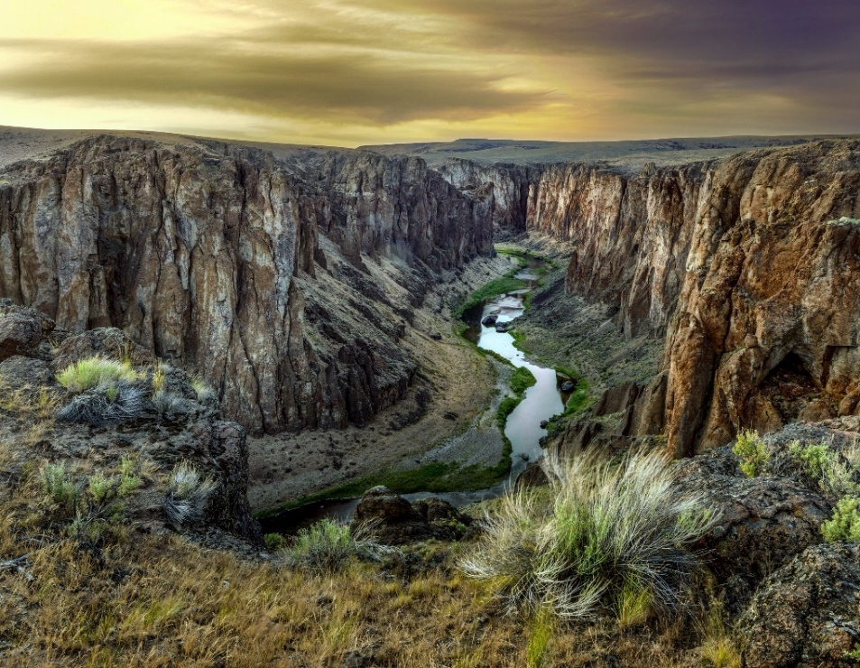

Recreational use in the county will continue for the most part to be associated with outdoor uses of the federal lands for hunting, fishing, trail riding, hiking, boating, and photography. Multiple uses of the federal lands will continue to be encouraged as this
provides the widest and best uses of the lands for both the general public and the grazing interests which are a major portion of the economy of the county.

Recreation, and Special Area Goals
- Encourage appreciation and preservation of the recreational, architectural, and cultural history and historic resources in Owyhee County.

Recreation and Special Area Objectives:
- Continue to support multiple uses of the public lands for recreation, grazing, timber, and mining.

- Control the spread of invasive species, noxious weeds, rodents and pests.

- Review ordinances to update development design standards to encourage incorporation of non-motorized path ways.

- Park designation of Idaho State Parks for any future development of parks on State land.
- Look for opportunities for the county to develop access points for recreation.

Housing:
Owyhee County is at an important crossroad. This plan will have a significant effect on how housing develops in a county which is primarily agricultural but is now experiencing an increasing growth rate.

Changes in the agricultural industry have resulted in consolidation of many farms into larger units thereby creating a scattered pattern of residential use in the farming areas. Houses that were formerly farm houses are in some cases now occupied by persons not involved in agriculture. Many of these people live in Owyhee County but commute daily to jobs in surrounding counties. Some of the former farm housing is in very good repair and condition, while some is in varying stages of dilapidation. At the same time, there has been an increasing rate of new housing construction in the rural areas.

There may be a need for both affordable and upscale housing. Acreage lots are in demand for both affordable and more expensive housing. Meeting these needs while at the same time improving the economic base and protecting the prime agricultural land will be a challenge. A uniform building code has been adopted by the County.

Housing Goal:
a. To guide development in ways that provide safe, equitable, and affordable shelter for all residents, while conserving agricultural land, maintaining rural character, and reducing pressure on public infrastructure and services.

Housing Objectives:
- To direct residential subdivisions to those areas that least conflict with agricultural enterprises.
- To develop land use classifications that direct residential subdivisions to areas that place the least stress on county and public services.

- To determine the need for adequate affordable housing, and its associated infrastructure, within the county in order to manage development and growth in accordance with this plan.

- To monitor and update as necessary the Area of Impact agreements that have been established with the cities.
- To maintain appropriate standards of health and safety by enforcing the Uniform Building Code in housing constructed in Owyhee County.

- To encourage cluster subdivisions instead of strip residential development along county roads.

- To discourage development in areas of the county that are remote from emergency, and county services.

- To site CAFO’S where they will be least in conflict with existing uses.

Natural Resources:
The natural resources of Owyhee County are what have attracted people to this area, kept them here, and will sustain them in the future. The existence and use of natural resources are greatly influenced by the climate and topography.

Owyhee County hosts a large variety of animal life. The native fish, birds and mammals have always been a resource for fishermen, hunters, and trappers for recreation and commercial purposes. Introduced domestic species, such as cattle and sheep, have easily acclimatized to this area enabling ranching to become the primary economic enterprise of the County

Because of the wide variety of soil types and climate variations, Owyhee County has a wide variety of plant life. The native species vary from semi-arid to aquatic plants; evergreens and deciduous trees; annuals and perennials, fruit bearing, seed bearing and tuberous; broad leafs; and grasses. They provide a rich variety of food for both native and domestic animals as well as a very limited resource for the timber industry.

The introduced vegetation for crops has provided the second largest contributor to the
economic base of the county. Farmers produce a large variety of crops for both human and animal consumption.

Invasive Species and noxious weeds occur within the County. Control of noxious and highly flammable weeds is essential.

The soils and geology sections describe the various soil types and minerals found in Owyhee County. Farming and mining are the two obvious industries in the county that use the minerals found here, but there is also a notable amount of quarry work done to provide the materials used in building and maintaining the public and private road system in the County. In addition, there is some geothermal activity in Owyhee County.
In its early history, mining was the county’s main industry. Mining has sporadically continued to the present time. Though the county still has reserves of ore, it is impossible to predict when and if this will be mined. Obviously, it would be unwise to base predictions on the future of the economy in Owyhee County on mining.

The following natural resource concepts have been considered:

1) Water. Water is probably the most valuable resource of Owyhee County. It is the essential element to maintain all plant and animal life. All industries of the County rely on the continued use of water and depend on legally recognized rights to collect, distribute, and use the water as it passes through the County. Any loss of rights to use water would cause immediate negative consequences to the County both economically and socially.

Groundwater is the primary source of water for human consumption and in recent years has been increasingly developed for irrigation purposes. Depletion and degradation of the aquifer is a very real danger to the county and should be monitored closely.

The primary source of surface water is snowpack melt and spring seepage in the mountains. Seasonal rains also contribute to the surface water source. Diverted live surface water was the first source of irrigation for the pioneer farmers of the County. It is still a major source of irrigation water. Increasing conflicts between the irrigation supply system and development must be carefully monitored. Standards for development should minimize these conflicts and must be established in order to preserve the county’s agriculture industry.

Reservoirs were developed for power generation, flood control and agricultural purposes. Reservoir water is used supplement live surface water in some areas. It has proven to be a reliable source of water for irrigation as it “holds” water until needed. Reservoirs have contributed to the recreational activities in the County. Boating and fishing are popular pastimes on reservoirs.

2) Geology. Owyhee County’s geology is diverse, with multiple regions that illustrate the area’s rich geologic history.

Owyhee Mountains
The Owyhee Mountains are characterized by rugged terrain and a mixture of geological formations. The region is primarily composed of Columbia River basalt and rhyolite, along with igneous rocks such as monzonite and volcanic sedimentary rock, a result of the Idaho batholith. These mountains run in a north-south direction and were formed during the Miocene and Pliocene eras (13 to 25 million years ago).

Owyhee Range & Southwest Plains
The Owyhee Range and the adjacent southwest plains are marked by farmlands, meadows, and remnants of ancient lake beds, also known as the rift zone. The landscape features lava domes, valleys bordered by faults and fractures, and igneous rock formations. These areas are primarily formed by volcanic processes and the Snake River basalt, which was deposited during the Miocene era. The region is tectonically active and is shaped by the forces of plate movement over millions of years.

Snake River Basin and Lowlands
The Snake River Basin and its surrounding lowlands are primarily composed of the Payette Formation. These geologic features include large granite batholiths lying beneath layers of silt, sand, and gravel. The region's rich soil composition is ideal for agriculture, supporting plains, sagebrush, and loamy, alkaline soils. The area also contains geothermal resources, making it an important site for energy development.

Canyonlands
Owyhee County's canyonlands are a dramatic feature of the landscape. The canyons in the area can reach depths of up to 800 feet, with rocky slopes composed of rhyolite and basalt. The unique erosional features in these canyons, known as hoodoos, have created some of the most striking and rugged terrain in the region. Notable canyon systems like the Bruneau Canyons, which reaches depths of over 1,000 feet, are known for their steep cliffs and dramatic geological features.

Additionally, the county is known for its deposits of rare earth minerals, with 11 different types found in the region. Notably, the Delmar Mine is rich in Naumannite, which is used in cosmetics, welding wire, plastics, and paint enamels. The county is also home to significant deposits of Chromite, an important mineral used in the production of stainless steel, iron alloys, and chromium plates, making the area vital for industries requiring these materials.

Minerals of Owyhee County
Owyhee County is rich in a diverse range of minerals, many of which are valuable for industrial, commercial, and scientific applications. Some of the notable minerals found in the county include:

- Acanthite: A silver sulfide mineral, commonly found in ore deposits. It is important in silver extraction.
- Arsenopyrite: A mineral that contains arsenic and iron, used in the production of arsenic compounds.
- Azurite: A blue copper carbonate mineral, often used as a copper ore and in the production of pigments.
- Barite: A common mineral used in the petroleum industry for drilling muds.
- Cassiterite: The primary ore of tin, used in the production of tin metal.
- Chlorargyrite: Known as "horn silver," it is an important source of silver.
- Diopside: A green-colored mineral found in some types of granite, used in gemology.
- Fluorite: A mineral that is a source of fluorine, used in the production of fluorine-based chemicals and in the manufacture of aluminum.
- Garnet: A group of minerals used as abrasives and in water filtration.
- Gold: Owyhee County has notable deposits of gold, historically mined for its high value in jewelry and industrial uses.
- Hedenbergite: A mineral found in some igneous rocks, used for its iron content in industrial applications.
- Quartz: One of the most common minerals, used in electronics, glassmaking, and as a gemstone.
- Silver: Found alongside other minerals like acanthite, it is valuable in the production of jewelry, coins, and electrical conductors.
- Stibnite: An important ore of antimony, used in flame retardants, batteries, and alloys.
- Vesuvianite: A rare mineral often used as a gemstone.
- Xanthoconite: A copper arsenic sulfide, known for its bright yellow color, used as an ore of copper.

These minerals, along with others such as cerussite, epidote, fluorite, pyrite, and pyrrhotite, reflect Owyhee County’s geologic diversity and economic potential. The county’s mineral wealth has been crucial to its history and development, supporting industries from mining to manufacturing.

3. Topography. Owyhee County features a varied topography that slopes from the southwest towards the northeast, with the highest elevations found in the Owyhee Mountains. Hayden Peak, the highest point in the county, reaches an elevation of 8,401 feet. The lowest points are along the Snake River, with Homedale at 2,210 feet and Marsing at 2,230 feet. The geographic center of the county averages about 5,000 feet in elevation, with Grasmere at 5,126 feet and Triangle at 5,280 feet. The overall terrain is diverse, offering expansive plateaus, deep canyons, and sweeping valleys.

4. Soils. The Owyhee County soils tend to be calcareous and alkaline, well drained and have salt and water problems in the lower valleys. However, some areas adjacent to the Snake River are very sandy with a high level of permeability and without layers of clay or other substrata which would protect the aquifer from agricultural or animal nutrients.

The Snake River soils are generally silty and clayey with somewhat restricted subsoil and substrata permeability formed in stratified sediments on terraces, basins, and hilly uplands.

The Owyhee Mountains, Owyhee Range, and highland area of the County have soils which are generally silty, formed in materials mired with rocky residuum-colluvium from basic rock types on plateaus, canyons, and mountains.

- Climate. Owyhee County is characterized by a semi-arid climate with mild to hot summers and cool to cold winters. Although temperatures may occasionally drop below freezing, such conditions are typically brief. The coldest recorded month in the past 50 years was December 1990, with an average temperature of 65°F, and the coldest nighttime average occurred during this time.

Owyhee County's diverse topography, which includes mountain ranges, canyonlands, and plateau regions, contributes to significant variations in temperature. On average, Owyhee County experiences warmer temperatures compared to many other areas in Idaho. While freezing temperatures occur on approximately 129 nights per year, extreme cold is generally confined to mountainous areas, where there are about 2.1 days per year when temperatures fall below freezing during the day.

Owyhee County, Idaho, experiences a semi-arid climate with significant variations in precipitation and snowpack across different regions. Annual precipitation typically ranges from 4 to 18 inches, depending on the location within the county. For historical precipitation data, the Grand View 4 NW National Weather Service Climate station reports a 30-year average annual precipitation of 6.68 inches for the period 1991–2020. Additionally, data from the Natural Resources Conservation Service for South Mountain from 1975 to 2020 indicates an average of 4.95 inches of precipitation per month, including summer months where typically no snow falls.

Owyhee County, Idaho, set its snowfall record 40 years ago. On May 2, 1983, the county received 60 inches of snow over a 24-hour period, according to NOAA. While such extreme weather events can skew average data, they are considered outliers. Over a longer span of years, these anomalies are balanced out by more typical weather patterns, providing a more accurate representation of the area's climate.

Over the past 50 years, the average temperature in Owyhee County has shown only a slight deviation, indicating a relatively stable climate overall, with minor fluctuations that are typical of long-term climate trends.

July is typically the hottest month of the year, with average temperatures exceeding 90°F for about 54 days. During this time, precipitation levels are at their lowest, and irrigation becomes crucial for agriculture.

In addition to temperature and precipitation patterns, Owyhee County is occasionally affected by high wind events, particularly during spring and summer thunderstorms. Wind gusts can exceed 60 mph, sometimes resulting in downed trees, damaged structures, and widespread power outages. Though not constant, these events can be disruptive and are a notable aspect of the county’s seasonal weather variability.

Hydrologic Systems and Irrigation. There are three basic hydrologic basins within the County which all drain into the Snake River:
The Bruneau River system covers the eastern half of the County and includes many tributary streams.

The Owyhee River drainage extends along the south side of the Owyhee Mountains, the Owyhee Range and generally over the entire southwestern plateau portion of the county. This water passes in and out of eastern Oregon before becoming part of the Snake River north of Owyhee County.

Irrigation from these water sources is most prevalent along the lower Bruneau and Snake River drainages. The Homedale area receives irrigation waters from Owyhee Reservoir in Oregon.

The maintenance and protection of the irrigation water supply and the delivery systems is one of the highest priorities for the County.

7. Vegetation. The natural vegetation of Owyhee County is limited by low annual precipitation and high evaporation during the growing season. Elevations below 3,000 feet are generally covered with bunch grass and sparse amounts of sage and other shrub steppe vegetation. Some local areas have no vegetative cover at all and have been smothered by sand dunes which constantly shift with the wind. Forest areas are generally confined to the Owyhee Mountains and Range in the westernmost portion of the county. Areas between 3,000 feet and 5,500 feet are usually covered with sagebrush on slopes facing north where less exposure allows more abundant growth of flora. Mountain peaks with elevations from 6,000 feet to 8,000 feet receive enough precipitation to support sagebrush, fir, and juniper. Forests are especially thin along protected ridges adjacent to mining areas where massive cutting took place during the boom era. The invasion of juniper is a problem in certain areas. The BLM has identified at least 25 special status plant species within the county that warrant some level of protection.

Wild and Scenic Rivers

The Omnibus Public Lands Management Act (P.L. 111-111) designated 316 miles of southern Idaho waterways as Wild and Scenic Rivers under the Wild and Scenic Rivers Act.
Congress created the National Wild and Scenic Rivers System in 1968 to preserve certain rivers with outstanding natural, cultural, and recreational values in a free-flowing condition for the enjoyment of present and future generations. The Wild and Scenic Rivers Act was sponsored in Congress by Senator Frank Church of Idaho.
There are three categories of rivers in the WSR system: wild, scenic, and recreational. Wild rivers are free of dams, generally inaccessible except by trail, and represent vestiges of primitive America. Scenic rivers are free of dams with shorelines or watersheds still largely primitive and shorelines largely undeveloped, but accessible in places by roads. Recreational rivers are readily accessible by road or railroad, may have some development along their shorelines, and may have been dammed in the past.

The following waterways have been designated Wild and Scenic

Owyhee River System
- North Fork Owyhee River
- Battle Creek
- Deep Creek
- Dickshooter Creek
- Owyhee River
- Red Canyon
- South Fork Owyhee River
- Big Jacks Creek and Little Jacks Creek Wilderness areas
- Big Jacks Creek
- Little Jacks Creek
- Cottonwood Creek
- Duncan Creek
- Wickahoney Creek
- Bruneau River System Bruneau River
- Jarbidge River System
- Jarbidge River
- Sheep Creek

8. Ground Water Resources (Aquifer). The County varies greatly in the availability and quality of groundwater. Some areas near the Snake River have an abundant supply while a few miles away even 3 gallons per minute for domestic use may be impossible to find. Dissolved minerals and gases often render the supply unusable without treatment. Development (residential, commercial, or industrial) will be limited in some areas because of the lack of potable well water. The availability of a suitable supply of domestic water must be confirmed before developments are approved. The availability of domestic water should be a factor in determining the appropriate zone on the zoning map.

A continuing concern will be the possible introduction of nitrates into the aquifer. Other agencies are monitoring and addressing this problem. The County may be involved in the process.

9. Wildlife. Owyhee County is home to more than 200 wildlife species. Golden eagles, red-tailed hawks, prairie falcons, owls, and other raptors nest in the canyons. Ungulate species in the county include elk, mule deer, pronghorn antelope and the largest herd of California bighorn sheep in the nation. Special status species include Redband trout, which occur mainly in shaded streams, and Columbia Spotted Frogs, which occur near permanent water along the edges of ponds or lakes or in pools along slower-moving streams. One of the most imperiled and important species in Owyhee County is the Greater sage-grouse, The U.S. Fish and Wildlife Service has identified the Owyhee country as one of six key strongholds for the Greater sage-grouse in the West. Sage-grouse rely on unfragmented sagebrush for cover, diet, nesting and brood-rearing, and they serve as an indicator species for overall ecosystem health. Pygmy rabbits have been proposed for listing under the Endangered species Act. They are found in areas of Owyhee County with dense sagebrush, which they use for shelter and food. At least 14 species of bats exist in the county, as do many species of birds and insects who serve as pollinators. Pollinators occur throughout the county, and changes to vegetation associated with development could adversely affect their populations. The BLM has identified at least 20 special status bird species within the county that warrant some level of protection.

Natural Resources Goals
- To protect and preserve the natural resources of the County by managing development and the use of those natural resources as necessary components of agricultural, commercial and recreational activities.

- Avoid unsuitable remote rural development by maintaining open space and access to natural resources through coordination of this Plan with the Owyhee County Land Use and Management Plan for Federal and State Land.

- Provide guidance and encourage engagement in federal land processes in attempt to protect the interests, goals and objective of this plan through coordination with the Owyhee County Land Use and Management Plan for Federal and State Land.

Natural Resources Objectives:
- Promote and encourage good stewardship of natural resources.
- Promote and encourage cooperation of various entities desiring to use natural resources in different ways.
- Protect the historical and customary rights of use, development, and enhancement of natural resources. As much as possible, do not take existing natural resources use from one user for the use of another.
- Identify and address issues that threaten the water resources of the County, and develop ways to mitigate these. Consider the impact of land use decisions upon the quantity and quality of water in Owyhee County.
- Any state, federal, or governmental actions shall follow the requirements of law and regulation regarding notification, coordination, and consistency with county policies and plans. Agencies shall contact and coordinate with the County in these areas.
- Carefully weigh the effect on natural resources from pollution or detrimental impacts before approving development of changes in historical use.
- Explore alternative uses for natural resources that “add value” to their use. An example of this is to develop an energy capturing system for removing invasive juniper from the landscape.
- Use all currently available information when making decisions that could potentially affect a renewable resource within the County.
- Continue the policy of multiple uses of public lands While preserving the historic uses of the landscape by maintaining the Owyhee County Land Use Management Plan for Federal and State Land. Also ensure contractor position is retained to provide comment and participate in public processes to ensure adequate comment is provided by the county.
- Discourage development in areas that do not have an adequate or suitable groundwater supply.
- Mitigate for fire risk by working collaboratively with state highway department to develop fuel breaks, and by spraying right of ways to reduce invasive weeds expansion.
- Support rural fire departments and rangeland fire associations in efforts to assist federal firefighters in suppressing wildland fire quickly to reduce acres burned.
- Encourage landowners to support sage-grouse habitat improvement.
- Encourage landowners to install roof-top solar panels on new and existing buildings.
- Encourage landowners to eliminate highly flammable vegetation from their properties and to establish fuel breaks where possible.
- Discourage development in and near sand washes that are prone to flash flooding.
- Continue to provide input about energy development on federal lands, specifically how it might affect private land (e.g., fire, water, hazardous waste)

Community Design:
Community design is established by the combined physical elements which contribute to the overall visual character of a place. The natural landscape, the form and arrangement of structures on the landscape, and the aesthetic continuity of neighboring parcels of land are the most common design considerations. Development will be encouraged to incorporate a reasonable measure of rural atmosphere, country life style and open space.
The natural beauty of unincorporated Owyhee County is its existing landscape dominated
by vast expanses of open rangeland, and undeveloped state and federal lands.

Community Design Goals:
- Encourage development within appropriate zones.
- Encourage preservation of cultural resources.
- Encourage preservation of open rangeland.
- Encourage preservation of recreation lands.
- Encourage preservation of open spaces.
- Coordination of land management objectives with federal agencies.
- Encourage new development to incorporate a reasonable measure of rural atmosphere, county life style and open space.
- Encourage compatible new development.
- Protect ground water and surface water resources from depletion by over development or contamination from commercial/industrial uses within the county recognizing that ground water is finite Discourage development in the unincorporated areas of the county

Community Design Objectives:
- Update zoning ordinance and map in accordance with this plan.
- Identify appropriate locations and standards for transition zones.
- Review setback rules to preserve open space and transportation corridors.
- Provide standards for commercial/industrial development
- Prohibit Confined Animal Feeding Operations in Residential zones.
- Encourage public utilities and utility corridors to be located on public lands
- Limit land splits in agricultural zones.
- Review subdivision ordinance design standards.
- Require Planned Unit Developments to set aside acreage for open space.
- Encourage cluster subdivisions or planned unit developments, instead of strip residential development along county roads.
- Limit residential development in agricultural zones except by conditional use permit.
- CAFO’s should be located where they will be least in conflict with other uses.
- Access to major roads should be limited and be designed to not negatively affect traffic flow or safety of the roads.
- Work toward the development and implementation of a sign ordinance.
- Establish a Code Enforcement Officer position to ensure compliance with allowed uses in each of the established zones and to ensure that the conditional uses within these zones are consistent with issued permits. The Code Enforcement Officer may conduct inspections of properties to verify compliance with issued permits and zoning regulations and investigate complaints regarding potential zoning violations and take appropriate enforcement actions.
- Prohibit wrecking yards and other industrial uses in multi-use zones.
- Prohibit utilizing campers outside of authorized parks for anything other than permitted temporary housing with a 3-month time limit.
- Require developers of a property to maintain it in a clean/weed free state until such time as it is fully developed. This includes managing construction waste while under development.
- Require property owners to maintain their property to prevent public nuisances, or detriment to surrounding property owners.
- Establish Development impact Fees to help mitigate the expense of growth on public infrastructure and services.

Economic Development:
The purpose of the economic development component of this Comprehensive Plan is to provide a current look at, and future goal for Owyhee County’s economy, and to analyze its desired growth potential in industry, and the locations where it will be best suited. This analysis will look at the local economy, occupation, income, and employment forecasts.

Local Economy:
Owyhee County’s economy depends mainly on agriculture and grazing. The county’s agricultural uses are a major component of the economic base. The local economy mainly consists of agricultural operations and small, privately owned businesses which support the local population. Large employers are mostly agricultural operations, government, and the school districts.

Businesses concentrate mostly in the commercial and multi-use zones, which are typically closer to existing services.

Fluctuating commodity and cattle prices coupled with increasing costs of production have placed a strain on the economic conditions of the producers and of the county. When these conditions will improve is entirely speculative. Environmental regulations, particularly water quality regulations, may have a severe impact on irrigated agriculture and dairy operations. More CAFO’s may seek to locate in Owyhee County, however, there may be challenges associated with sufficient quality and quantity of water, waste disposal, and conflict with residential uses.

There has been a great deal of development pressure as people who live in surrounding and rapidly growing states and counties, seek to reclaim a slower and more rural lifestyle. Land suitable for commercial and residential development will continue to be in demand. Property values have continued to increase driven by this demand. Fluctuating commodity prices and erratic economic conditions continue to add additional challenges to Owyhee County’s economy.

Retail opportunities have increased within Homedale, Marsing, and Grand View which may draw more people to those areas and help strengthen those small communities.
The most current data from the Department of Labor indicates the following conditions in Owyhee County:

Total Jobs: | 2013 | 2023 | 2025
Agriculture | NA | 1188 | 1221
Mining and Natural Resources | 1290 | 939 | 939
Construction and Manufacturing | 81 | 190 | 61
Trade, Utilities & Transportation | 373 | 656 | NA
Information | 25 | 27 | NA
Financial Activities | 32 | 32 | 34
Professional /Business Services | 159 | 151 | 209
Education & Health Services | 534 | 583 | 599
Leisure & Hospitality | 127 | 250 | 243
Other Services | 12 | 47
Government | NA | NA | 216

As of March 2025, Owyhee County is experiencing a period of economic stability, with modest growth in certain sectors and challenges in others. Projected job numbers past 2025 are not available, possibly due to not enough historical data to make a reliable projection, rapid economic changes, new industries and various external factors.

Economic Development Goal:
Where appropriate, and consistent with the goals and objectives of the Comprehensive Plan, and zoning regulations, support commercial, light industrial, and other economically beneficial uses that provide employment and support Owyhee County residents without added tax burdens to the county or its citizens.

Objectives:
- Prioritize and protect the agricultural base, farming, ranching, and grazing so that it remains an important and viable part of the economic base of the County.
- Promote a balanced multiple use of public lands so that they remain open to the uses that are historic and customary (Recreation and grazing).
- Create conditions that support new commercial, light industrial, and low impact home based business development by minimizing regulations in appropriate zones, and streamlining building and development processes.
- Cooperate with the cities and Chambers of Commerce to expand existing retail business and encourage new retail business into appropriate areas of the County.
- Develop strategies within the plan to help support cities and towns, and encourage revitalization of existing facilities for new economic uses.
- Evaluate and encourage annexation by Cities of property being developed within Areas of Impact.

Capital Infrastructure
Capital infrastructure planning is essential to ensuring that Owyhee County can accommodate current and future service needs while preserving its rural, agricultural character. In 2024, Owyhee County adopted the Master Facilities and Comprehensive Financial Plan (MFP/CFP), which provides a framework for evaluating facilities, projecting future needs, prioritizing capital investments, and aligning long-term financial planning with growth and service delivery.
A Capital Improvement Plan (CIP), as guided by the MFP/CFP, serves as a multi-year roadmap for identifying, budgeting, and financing capital projects. These projects may include:
- Road and bridge infrastructure to support safe and efficient transportation across the County’s vast rural landscape.
- Water, wastewater, and drainage systems that ensure public health, environmental protection, and agricultural viability.
- Public buildings that provide safe, functional, and efficient spaces for County services.
- Parks, trails, fairgrounds, and recreation facilities that enhance quality of life while supporting rural tourism and community activities.
- Public safety and emergency management facilities that ensure adequate service coverage in remote areas.
- Major equipment purchases necessary for County operations, particularly in road and bridge maintenance.
The MFP/CFP emphasizes both prioritization of needs and fiscal discipline, ensuring that capital decisions align with available resources, projected revenues, and the long-term sustainability of County services.

Capital Infrastructure Objective
Ensure that capital improvements are identified, prioritized, and funded in a manner that supports public health, safety, and welfare; preserves agricultural land and rural character; and maintains the County’s ability to deliver essential services in step with growth and community needs.

Capital Infrastructure Policies
- Owyhee County will use the adopted Master Facilities and Comprehensive Financial Plan as the guiding framework for identifying, evaluating, and budgeting capital infrastructure needs.
- Capital improvements will be prioritized based on need, service impact, cost-effectiveness, and consistency with adopted financial planning strategies. Projects will be funded through a mix of County resources, grants, intergovernmental partnerships, and where appropriate, impact fees or other developer contributions.
- As the County grows, capital investments will be made to maintain the current level of service for existing residents, while exploring all avenues of requiring new development to contribute proportionately to the infrastructure demands it creates.
- The Board of County Commissioners, in coordination with County staff and departments, will periodically review the CIP and MFP/CFP recommendations to update priorities, and adjust cost estimates.
- Infrastructure planning and investment decisions will balance growth and service needs with the protection of farmland, open space, and rural landscapes that define Owyhee County.

Public Services and Facilities:
Owyhee County is a large and sparsely populated county. Much of the County is remote with few improved roads, and no utilities or services. Most of the services and facilities that do exist are in or near the populated areas.
As of the date of adoption, the current services available are as follows:
- There are no hospitals in the County; the closest hospital facilities are in Caldwell, Nampa, Boise, Mountain Home, and Owyhee Nevada. Ambulance service is provided in Homedale, Marsing, Grand View and Owyhee Nevada provides services for the southern end of the county near the Duck Valley Indian Reservation. Bruneau, Melba, and Jordan Valley have Quick Response Units. Life Flight is available from Boise. Limited care clinics are located in Homedale, Marsing, Grand View and Melba. There are dental and chiropractic services available in Homedale.
- Marsing, Homedale, and Grand View have Senior Citizen Centers and Homedale has one nursing home. Melba has a senior citizen center that serves the Melba (and surrounding) area of Owyhee County.
- Waste sites available are Opaline Tipping Station, Homedale Transfer Station, , and various dumpster locations. The County is looking into long term solutions for waste disposal needs.
- Water supply for all of the communities in Owyhee County is from groundwater sources. Homedale, Marsing, Murphy, Grand View, Bruneau, and Silver City have central water systems although not all of them serve their entire community.
- Homedale, Marsing, Bruneau, and Grand View have central sewer systems with the rest being served by septic systems. Solid waste disposal is available in most of the communities.
- Homedale, Marsing, Murphy-Reynolds-Wilson, Grand View, and Bruneau have volunteer fire departments. Homedale has its own police department with the remainder of the communities being served by the County Sheriff’s Department.
- Homedale, Grand View, Marsing, and Bruneau have public libraries.
- There are four public airports in the County: Homedale Municipal, Murphy, Grasmere, and Murphy Hot Springs. Several private and emergency strips are also located in the County.
- Idaho Power serves the more populated parts of the County. Landline telephone service is available in the more populated areas. Cellular service is available along major roads and in cities, but limited or nonexistent in remote areas.
- Homedale Highway District serves the Homedale area, Gem Highway District serves the Marsing area, Three Creek-Good Roads District serves the southeastern part of the County. The Pleasant Valley area, Murphy area, Grand View area, and Bruneau area are served by the Owyhee County Road and Bridge.
- The Gem Irrigation District of the South Board of Control serves the Homedale-Marsing area. Other irrigation entities are: Opaline Irrigation District, Bruneau Buckaroo Co-op Ditch Company, Hot Springs Co-op Ditch Company, Southside Bruneau Canal Company Limited, Grand View Canal Company, and the Upper Grand View Canal, Grand View Mutual Irrigation Company, Reynolds Irrigation District, and Little Valley Mutual. The remainder of the irrigation in the County is by individual or private entities.

Public Services and Facilities Goals:
To maintain, protect and enhance public services and facilities.
To require that an applicant for a land use change assess the impact that such change would have upon the public services and facilities and present such information to the planning Commission with the application. Mitigation for such impact may be required.

To be consistent with the Owyhee County Multi Hazard Mitigation Plan, and the Owyhee County Emergency Operations Plan where applicable to land us

Utilities and Energy:
In late 2007 Owyhee County adopted the Owyhee County Energy Plan. Owyhee County was the first in Idaho to develop and adopt such a plan. However, that plan was recently repealed and a new advisory committee has been formed to develop an energy plan for Owyhee County. When such plan is complete and adopted by the Board, the Comprehensive Plan will be updated to be consistent with the new plan as it relates to land use.

In 2005 a portion of the West Wide Energy Corridor was designated through Owyhee County. At the time of this writing, the Gateway West and Boardman to Hemmingway project have been approved through Owyhee County. These projects are 500 KV transmission lines. Gateway West begins in Wyoming and terminates at the Hemmingway Substation. The Boardman project begins in Boardman Oregon and also terminates at the Hemmingway Substation. Having the West Wide Energy Corridor designated on Federal land in Owyhee County has opened a door for the siting of future public utility proposals.

In recent years, Owyhee County has seen a very substantial increase in the number of energy related proposals on private, state, and federal land. On public lands, balancing these projects with historic grazing, mining, and recreation is proving to be challenging.

Projects on private land have also proved to be challenging to balance siting the appropriate amount of energy infrastructure while also preserving the property values and peaceful enjoyment of private property owners adjacent to these proposed projects. As stated in other parts of this plan, Owyhee County is heavily dominated by public lands. Given that only 17 percent of Owyhee County is privately owned, the County seeks to ensure that the siting of energy infrastructure is proportional to local needs, consistent with land use policies, and not disproportionately concentrated in Owyhee County.

Communities around the Treasure Valley have seen an increase in interest from data centers locating here. These centers consume a vast amount of power which would present a major shortfall for Owyhee County. Such proposals would have to be very carefully scrutinized for the impacts they would create and possible needs that would arise if such a project was to be approved in Owyhee County.

Comments received from survey respondents generally supported small scale energy projects for personal home use but the majority of comments were opposed to commercial and industrial scale projects especially if they would cause a negative impact to agricultural use.

Legislation passed in 2025 changed the way that utility projects are taxed. The current model of collecting tax revenue for these projects is based off kilowatt production rather than valuation. This means the county would not receive any tax revenue for projects that are not actually producing power.

It is the intent of the people of Owyhee County that these proposed projects be carefully considered and analyzed for impacts to our county and approved only when not in conflict with the comprehensive plan and zoning regulations where they are proposed. It is also the intent of the people of Owyhee County that we only allow for our proportional share of energy projects and related infrastructure. Owyhee County has faced decades of catacrotic fires which pose a serious threat to the county and its economy. It is the intent of this plan to caution officials that large-scale energy infrastructure brings wildfire, security, and maintenance risk.

Utility and Energy Goals:
Protect the property rights of Owyhee County citizens and not allow the infiltration of public utilities and energy projects and corridors to negatively impact those citizens or their private property.
carefully considered and analyzed for impacts to our county and approved only when not in conflict with the comprehensive plan and zoning regulations where they are proposed.
only allow for our proportional share of energy projects and related infrastructure.

Cautiously consider the cumulative Impacts of multiple energy projects.
energy siting in agricultural zones should only be approved when it is consistent with agricultural land preservation and does not cause any adverse impacts to existing agricultural uses.

If an energy project is approved on state or federal land, greater consideration will be given to projects proposed on adjacent private land so that the private property land owner can realize a benefit from having to be burdened by the project on public land.

Hazardous Areas:
The County Building Official and the Planning and Zoning Administrator will work with state, federal, and local authorities to work toward identifying and mapping areas of the County known to be hazardous and on which development might need to be restricted. Currently existing hazardous waste sites will be identified on the County zoning map.

Transportation:
The major transportation system in Owyhee County is the highway and road system. State Highway 19 traverses the northern portion of the County from the Oregon State line through Homedale and into Canyon County. U.S. Highway 95 links the County from Homedale south to the Oregon State line near Jordan Valley. State Highway 55 runs from two miles west of Marsing and through Marsing to the Canyon County line. State Highway 78 runs from Marsing through Grand View and Bruneau on to Elmore County. The Junction of Highways 78 and 51 is located approximately two miles west of Bruneau and runs south to Nevada and north to Elmore County
Many miles of improved and semi-improved County roads access some of the remainder of the County. The rest is accessible by horseback or on foot. Rail service to Homedale and Marsing was discontinued in 1998.

The County will take the lead in promoting effective communication with other jurisdictions and agencies that manage roads within Owyhee County to help ensure that the planned growth aligns with available transportation infrastructure.

County leaders are well-positioned to set priorities for the use of county resources. At present, improvements are needed along Highway 55 and 78, which serve as key routes into and out of the city of Marsing.

Transportation Goals:
To provide the citizens of the county with a robust, reliable transportation system well into the future.

Transportation Objectives:

To develop, execute and deliver a plan that will support the changing transportation needs of the county into the next decade.

To work closely with state, county and city leaders, as well as other stakeholders, to promote transportation improvements that achieve the best possible outcomes for all citizens..

School Facilities:

Introduction:
The purpose of the school component of the comprehensive plan is to analyze the public school system that serves Owyhee County. This section shall serve as a conceptual framework to assist Owyhee County in future decision making regarding school facilities and school related transportation.

Objective:
It is the desire of the people of Owyhee County to carefully plan for the future needs of our population. This will be accomplished by implementing and maintaining a mechanism designed to closely coordinate with the School Boards in order to provide consistency between the Comprehensive Plan, County Ordinances, and school facilities programs and policies as they relate to land use, development and population growth.

Policies:
Coordinate applications for subdivisions, changes to future land use, or zoning for residential development to ensure adequate school capacity is available to residential development consistent with current level of service provided.

The Planning and Zoning Commission will manage the timing of new development to coordinate with adequate school capacity. Where capacity will not be available to serve students from the property seeking a change, and the developer is unable to provide adequate mitigation, the County may use the lack of school capacity as a basis for denial of residential development.

When making land use decisions, the Planning and Zoning Commission will give great consideration to School Board and Administrative Staff comments concerning the developments impact to schools.

Residential subdivisions proposed outside of existing school bus routes will be discouraged and may be denied if the development will cause an adverse fiscal impact to the school district and the developer is unable to provide adequate mitigation.

Owyhee County will implement and maintain development standards to reduce hazardous walking conditions for school age children going to and from schools or school bus stop locations.
New development and redevelopment adjacent to school properties will be required to provide a dedicated paved public access for pedestrian travel to existing and planned school sites.

For new development and redevelopment within two miles of an existing or planned school facility that will serve students, the County may require the installation of sidewalks within or adjacent to the rights-of-way of any public or private road within or abutting the site, so that a complete, unobstructed, continuous route with a minimum width of four feet paved to County specifications is provided along said roadways. If a road with a speed limit exceeding 50 mph exists within route to the school facility, then a three feet separation between the sidewalk and the road is required.

As part of the technical review process for subdivisions, Owyhee County will provide proposed projects to the effected School Board for review and comment for school siting; and Additional relevant information related to number of residential dwelling building permits for the preceding year, future land use map amendments, and population projections.

Homedale School District: This is the largest district in the county, serving 51% of the school aged children.

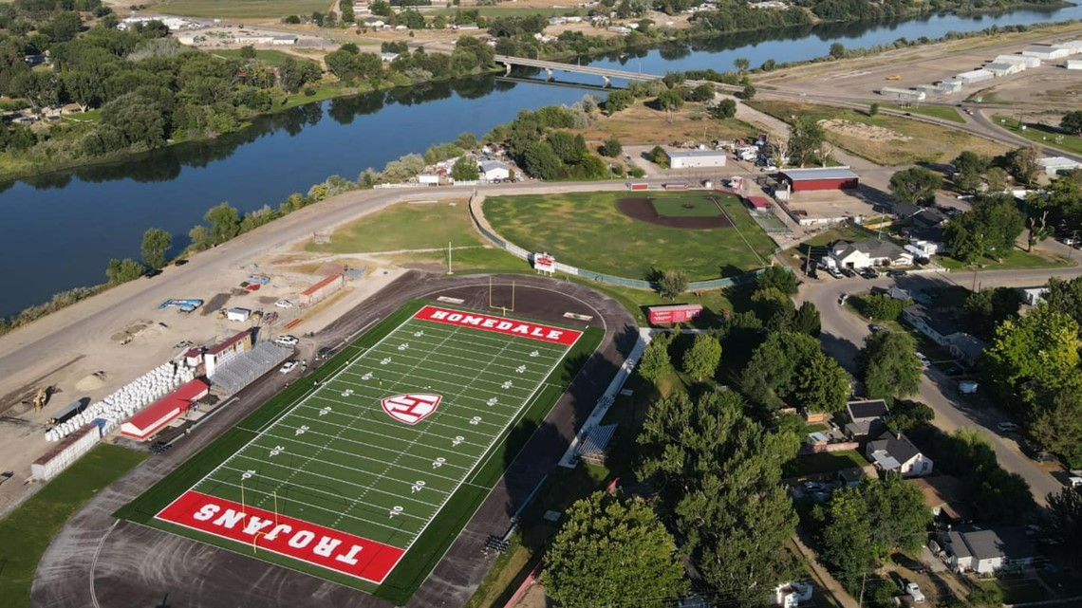

From 2010- 2025, the Homedale school district saw an 8.5% increase in enrollment.

The school buildings are in good condition. The District has embarked upon a regular maintenance schedule in an attempt to keep the facilities in good operating condition. All buildings are ADA accessible except for the second floor of the high school and are safe for continued use.
The students of the Homedale School District are served by a district owned bus system using eleven regular school buses covering 415 miles a day. The majority of these miles are on county roads in Owyhee and Canyon Counties. The Owyhee County Road Department and the Homedale Highway District work closely with the district to maintain safe bus routes under all conditions. As homes are built throughout the county, the school board is faced with the issue of providing transportation for more and more children. U.S. Highway 55 runs throughout the county, the U.S. Highway 95 and State Highway 19 run through Homedale. The school district and the Idaho Transportation Department have attempted to provide the safest possible environment around the
schools.

The Homedale School District consists of three school sites, one district office, and a bus garage site. The District owns seven buildings. They are all within the city limits of Homedale. Almost 60% of the students attending Homedale School reside outside the city limits. The 2024-2025 General Fund budget was $14,594,406 and the district indebtedness is $3,516,390. The Homedale School District owns 110 cultivated acres on the west side of Homedale. The land is being reserved for future school expansion.
The enrollment of the Homedale School District and plans for expansion are dependent upon the economy. The district is watching the employment patterns in the Boise Metropolitan Area and other businesses for future growth.
Bruneau-Grand View Joint School District No. 365. By square miles of area, this is the largest district in the county, currently serving 264 school aged children.

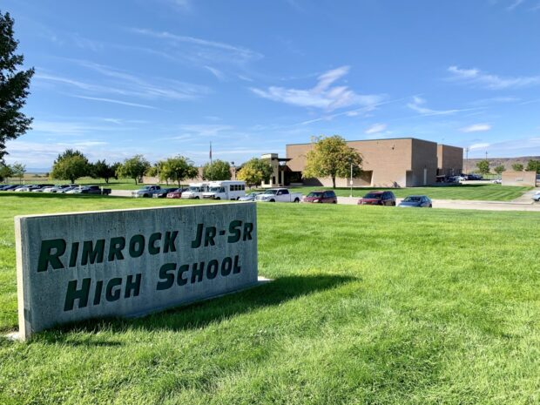

The Bruneau-Grand View District has seen a 21.2% decline in enrollment since 2010.

District passed a $650,000 supplemental levy in 2024 All buildings are ADA accessible and are safe for continued use.

A District owned bus system with 3 routes, serves 159 students of the Bruneau-Grand View District. These routes cover 420 miles per day. The majority of these miles are on county roads. The Owyhee County Road Department and Owyhee County Highway District work closely with the district to maintain safe bus routes under all conditions. As homes are built throughout the county, the school board is faced with the issue of providing transportation for more and more children. U.S. Highway 51 runs through Grand View and Bruneau. The school district and the Idaho Transportation Department have attempted to provide the safest possible environment around the schools.
The Bruneau-Grand View Joint School District consists of three (3) school sites and one district office. These buildings are within the incorporated area of Grand View and Bruneau, all located within Owyhee County.

Almost fifty-five (55) percent of the students attending Bruneau-Grand View Schools reside outside the city limits. The 2024-2025 General Fund budget was $ 5,139,607 and the proposed 2025-2026 budget is $5,178,904 and the district indebtedness is $977,807. The Bruneau-Grand View District does not own any cultivated acres.

Marsing School District: This is the second largest district in the county, serving 37% of the school aged children.

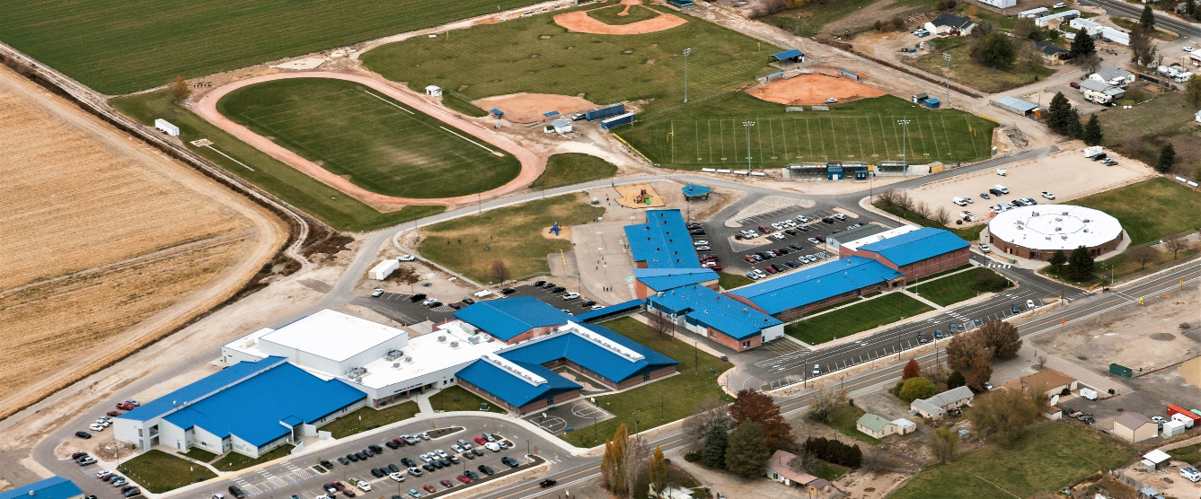

From 2000 – 2009, the Marsing School District saw an 18% overall increase in enrollment.

The school buildings are in good condition. The District has embarked upon a regular maintenance schedule in an attempt to keep the facilities in operating condition. All buildings are ADA accessible and are safe for continued use.

The students of the Marsing School District are served by a district owned bus system with eleven regular routes. Buses cover approximately 318 miles a day. The majority of these miles are on rural, country roads.
The Marsing School District consists of three school sites, one district office, one cafeteria, and a bus garage site. The District owns 7 buildings all of which are located within the city limits of Marsing. 1 modular building, owned by COSSA is located on the campus. Almost 76% of the students attending Marsing schools reside outside the city limits. The 2024-2025 General Fund budget was $5,025,944 and the district indebtedness is $3.595 million. The Marsing School District owns thirty-three (33) acres located on highway 78 and Highway 55, of the 33 acres, sixteen (16) are irrigated.

Melba School District: The Melba schools are located in Canyon County and serve patrons/students in Ada, Canyon, and Owyhee Counties. The district boundary in Owyhee County borders the Marsing School District to the north, the Bruneau-Grand View to the south, historic Silver City to west and along the beautiful Snake River creates the district’s eastern border of Owyhee County.

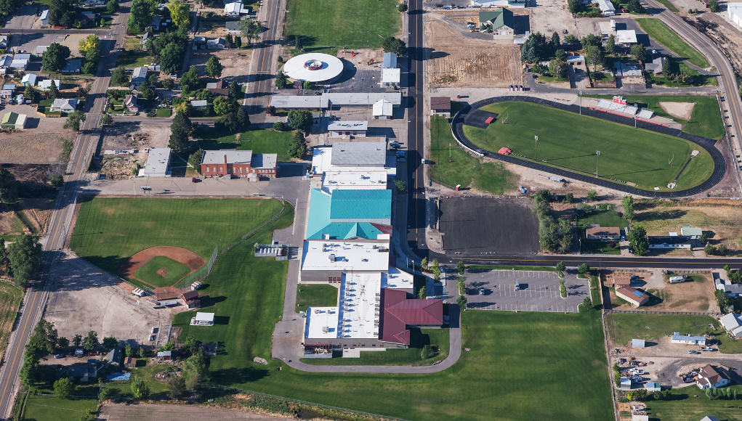

From 2000 to 2009, the Melba School District experienced fairly flat enrollment. In 2007-2008 it appeared that the district may experience a sharp enrollment increase which could have doubled the size of the schools. However, with a lagging economy and the end of a housing boom, there was little to no impact on the school district.

The school buildings are generally in good shape. The Middle/High School opened in 2003 and continues to be an asset to the district and community. The Elementary School buildings are older but well maintained. The District uses two modular buildings for classroom and office space. The District owns approximately eight acres on the south edge of the city which is planned for a new elementary school.

Melba School District owns and operates the school bus system. Because of the rural nature of the Melba School District approximately 85% of students are eligible to ride one of the 11 routes covering more than 500 miles per day. Approximately 20% of MSD students live in Owyhee County and use the transportation services offered by the school district. In some instances students must be transported to a bus stop. The District works cooperatively with Nampa Highway District, Ada County Highway District and the Owyhee County Highway District to provide the safest school bus routes.
The 2009-2010 General Fund budget was set at $7.3 million. The District has $4.36 million bond indebtedness. The District currently is operating with a $410,000 one year supplemental levy. The School District has approved supplemental levies since 2005.

The enrollment of the Melba School District and plans for expansion are dependent upon the economy. The District watches the employment patterns of the Greater Treasure Valley, agriculture trends, and other business for future growth.

School Facilities Goals:
Administer land use planning process in a manner which can assist the school districts in maintaining, protecting, and enhancing school facilities and transportation system.

To require that an applicant for a land use change assess the impact that such change would have upon the school facilities and transportation systems and present such information to the Planning Commission with the application. Mitigation for such impact may be required.

Plans Incorporated By Reference
The Comprehensive Plan should be consistent with other county adopted plans and policies.

Within the Comprehensive Plan are references to other plans. These plans are included by reference in the Comprehensive Plan for consideration in proposed projects and programs to be considered in the planning process. Since the size of the referenced plans are substantial, the decision was made to include them by reference only. All of the referenced documents and future amendments are adopted and are available for review at the Planning and Zoning office. Referenced plans include:
- Multi Hazard Plan
- Owyhee County Land Use and Management Plan (Natural Resources Plan)
- Sage Grouse Plan
- Energy Plan
- Fire Mitigation Plan
- County Master Facilities and Comprehensive Financial
- Plan (MFP/CFP or Plan) 2025.
- Homedale Fire Capital Improvement Plan 2025
- Marsing Fire Capital Improvement Plan 2025
- Marsing Ambulance Capital Improvement Plan 2025

Implementation
This Comprehensive Plan was created in accordance with the Local Planning Act of 1975. The purpose of the act is to promote the health, safety, and general welfare of the people of the State of Idaho. This Plan is designed to promote those values. The Plan, and the process of implementation of the Plan is to: Protect property rights and enhance property values; ensure adequate public facilities and services at a reasonable cost; protect and enhance the economy of the county; ensure protection of important environmental features, protect prime agricultural lands and mineral resources, encourage urban development within and near cities; ensure development consistent with the land’s physical character, protect fish, wildlife and recreational resources’ and to avoid water and air pollution.

The goals and objectives stated in the Plan document, and which have led to development of the zoning map, will be implemented in the following manner or by other methods:

- The zoning ordinance which shall be modified after completion of the Plan in order to implement the Plan.
- The Subdivision Ordinance will be modified to implement and supplement the Plan in order to carry out the County’s policies with regard to development of subdivisions.
- The Comprehensive Plan will be reviewed by the Planning and Zoning Commission on an annual basis.

