AGENDA |  | OWYHEE COUNTY PLANNING & ZONING
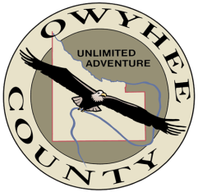  July 27, 2022 |  | Scott Jensen – Chair  Chad Nettleton – Vice Chair  Rich Curtis – Commissioner  Bob Thomas – Commissioner  Dean Young – Commissioner  17069 Basey St., Murphy, ID 83650

9:30 am
* Action Item

11:00 am
* Action Item

1:00 pm
* Action Item

The Commission will hear application Z22-22 filed by Idaho Power Company seeking approval of a conditional use permit to establish a battery energy storage system at their Hemingway Substation off Wilson Cemetery Road, 0.3 miles west of the intersection with Highway 78, approximately 6.5 miles southwest of Melba.

The Commission will hear application Z21-21 filed by Hidden Valley Investments LLC/ Phil Warner seeking approval of the final plat for Hidden Valley Estates No. V, a 19-lot residential subdivision on 31.7 acres located approximately 3.5 miles south of Marsing.

The Commission will hear application Z22-23 filed by Amanda Harpe seeking approval of a conditional use permit to establish a commercial riding arena and event center. The subject parcels are located at 5331 Old Sullivan Rd. in Homedale.

Any person in need of special accommodations to participate in the above-noticed meeting should contact the Community Planning office at least seven days prior to the meeting.

Copies of all materials for proposed projects are available for review in the Community Planning office or on our web page at: https://owyheecounty.net/departments/community-planning/public-hearing-documents/. For additional information, please contact planning staff at 208-495-2095 ext. 2, Owyhee County Annex Building, 17069 Basey St., Murphy, Idaho 83650.

* Action Item is a matter upon which the Commission may make a decision (Idaho Code §72-204)

