AGENDA |  | OWYHEE COUNTY PLANNING & ZONING
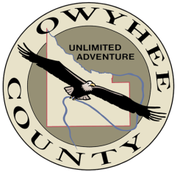  February 19, 2020 |  | Scott Jensen – Chair  Chad Nettleton – Vice Chair  Rich Curtis – Commissioner  Bob Thomas – Commissioner  Dean Young – Commissioner  17069 Basey St., Murphy, ID 83650

9:30 am
* Action Item

10:30 am
* Action Item

1:00 pm
*Action Item

3:00 pm

4:00 pm

The Commission will hear Application Z20-10 a request for a conditional use permit filed by Angela Stears seeking approval to establish a 16.28kW ground mounted solar array for residential use located on an approximately 8-acre parcel at 16390 State Highway 78, Melba, Idaho.

The Commission will hear application Z20-11 a request for a conditional use permit filed by Jens Schkade seeking approval to establish three 16.28kW ground mounted solar arrays for residential use located on an approximately 2-acre parcel at 25688 Boundary Lane, Grand View, Idaho.

The Commission will hear application Z20-06 a request for a conditional use permit filed by Dale VanEs seeking a conditional use permit to expand his current Dairy - Confined Animal Feeding Operation (CAFO) operation located at 8224 Desert Drive, Marsing, Idaho. The request seeks to expand the permitted number of animals from 7,500 to 12,500.

Review Oreana to Indian Cove surveys and comments. Discussion of next step.

Adjourn

Any person in need of special accommodations to participate in the above-noticed meeting should contact the planning and zoning office at least seven days prior to the meeting.

Copies of all materials for proposed projects are available for review in the planning and zoning office. For additional information, please contact planning staff at 208-495-2095 ext. 2, Owyhee County Annex Building, 17069 Basey St., Murphy, Idaho 83650.

* Action Item is a matter upon which the Commission may make a decision (Idaho Code §72-204)

