AGENDA |  | OWYHEE COUNTY PLANNING & ZONING
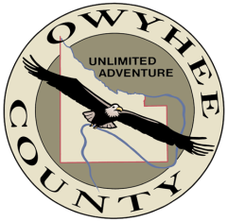  December 19, 2018 |  | Connie Brandau – Chair  Scott Jensen – Vice Chair  Chad Nettleton – Commissioner  Bob Thomas – Commissioner  Rich Curtis – Commissioner  17069 Basey St., Murphy, ID 83650

10:00 am
* Action Item

11:00 am
* Action Item

12:00 pm
Application Z19-03 a request for a conditional use permit filed by W. Keith Goering II seeking approval to establish a second single-family residence on a 35-acre parcel of land located at 10596 Johnston Road, Melba, Idaho.

The Commission will review citizen comments and proposed zoning map revisions for the areas from Marsing to south of Murphy and make a recommendation to the Owyhee County Board of Commissioners.

Adjourn

Any person in need of special accommodations to participate in the above-noticed meeting should contact the planning and zoning office at least seven days prior to the meeting.

Copies of all materials for proposed projects are available for review in the planning and zoning office. For additional information, please contact planning staff at 208-495-2095 ext. 2, Owyhee County Annex Building, 17069 Basey St., Murphy, Idaho 83650.

* Action Item is a matter upon which the Commission may make a decision (Idaho Code §72-204)

